**The First Project: Explore Weather Trends**

The steps I followed to complete the project are listed below:

* 1. **I wrote 3 queries to extract the required data. I used the workspace that is connected to**

**the database in Udacity**

* To know the closest city to where I live, I checked the listed cities in the city_list table by

using this query:

SELECT *

FROM city_list;

* To select the local data, I wrote the following query:

SELECT *

FROM city_data

WHERE city=’Riyadh’;

* To select the global data, I wrote the following query:

SELECT *

FROM global_data;

* 1. **I downloaded the CSV files and open them using MS Excel software.**
  2. **For each set of data (local & global), I calculated the 10-year moving average.** I decided to use this value because the dataset is large so, when I use the average of each 10 years, it will be visualized clearly and smoothly in the chart.
* The image below shows how I calculated the moving average for the local data. For example, in the cell E10, I calculated the average of the temperature values in the first 10 rows of the local data (Using the AVERAGE function). I used the same method to calculate the average of each 10 values.



* The image below shows how I calculated the moving average for the global data. For example, in the cell Q10, I calculated the average of the temperature values in the first 10 rows of the global data (Using the AVERAGE function). I used the same method to calculate the average of each 10 values.



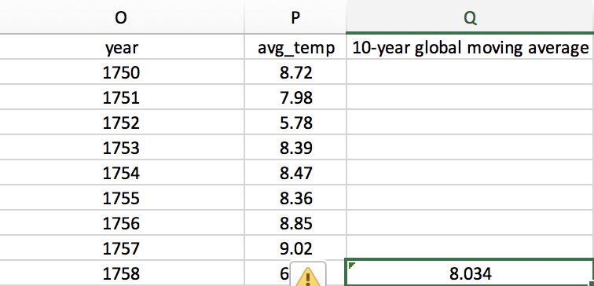

* 1. **I used the “line chart” to visualize the data shown below:**

When I tried to include the “year” values in the chart:



When I tried to switch the row and column, the following message appear:



* 1. **Observations (Similarities & Dissimilarities):**
* For the local level, the temperature increased and approximately stayed stable for

a long time then, it increased again.

* For the global level, after a long while, the temperature declined then, it started to

increase again and then stayed stable.

* On average, the local city “Riyadh” is hotter comparing to the global courtiers. The temperature difference between them(Riyadh & global countries) is consistent over

time.

* In general, the local temperature is consistent at 24 to 25 degree while global

temperature is consistent at 8 degree.